File Permission Task

Task Description:

Create a file with .txt extension (/home/demo.txt).
Command : touch /home/yoga/demo.txt

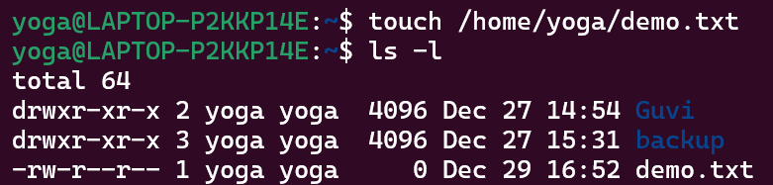

Change the permission set of that file, so that any user can read it, group can read/write & owner can read/write/execute it.
Command: chmod 764 demo.txt
